ECON 101 – Macroeconomics
MIDTERM EXAM #2
EXAMINER: MUHEBULLAH KARIMZADA
March 19, 2026

Instructions:
1. You have 70 minutes to work on the exam.
2. This midterm is individual and closed-book.
3. For the multiple-choice questions, choose the option that best answers/completes the question.
4. This Examination paper includes 12 pages (includes the cover page). You are responsible for ensuring that your copy of the paper is complete. Bring any discrepancy to the attentions of your invigilator.

PLEASE: PUT YOUR NAME AND STUDENT ID ON EVERY SHEET!!
Multiple Choice Answers:

1. _________ 15. _________ 29. _________ 43. _________

2. _________ 16. _________ 30. _________ 44. _________

3. _________ 17. _________ 31. _________ 45. _________

4. _________ 18. _________ 32. _________ 46. _________

5. _________ 19. _________ 33. _________ 47. _________

6. _________ 20. _________ 34. _________ 48. _________

7. _________ 21. _________ 35. _________ 49. _________

8. _________ 22. _________ 36. _________ 50. _________

9. _________ 23. _________ 37. _________ 51. _________

10. _________ 24. _________ 38. _________ 52. _________

11. _________ 25. _________ 39. _________ 53. _________

12. _________ 26. _________ 40. _________ 54. _________

13. _________ 27. _________ 41. _________ 55. _________

14. _________ 28. _________ 42. _________

MULTIPLE CHOICE. Choose the one alternative that best completes the statement or answers the question.

1) Actual real GDP will be above potential GDP if
A) firms are producing below capacity.
B) firms are producing above capacity.
C) inflation is rising.
D) firms are producing at capacity.
E) the current price level is lower than the price level in the base year.

2) Inflation is measured
A) using the level of the consumer price index.
B) using the level of real GDP.
C) as the change in the value of the Canadian dollar.
D) as the percentage change in the consumer price index.
E) as the percentage change in real GDP.

3) According to Robert Fogel, economic growth ________ health, and health ________ economic growth.
A) worsens; improves
B) does not impact; does not impact
C) improves; worsens
D) worsens; worsens
E) improves; improves

4) Since 1980,
A) the average length of expansions in Canada has become longer.
B) the average length of expansions in Canada has become shorter.
C) economic expansions in Canada have been so short that expansions barely exist.
D) the average length of a recession has fallen to zero.
E) the average length of expansions in Canada has remained about the same.

5) What is one difference between stocks and bonds?
A) Stocks represent partial ownership in a firm, while bonds do not.
B) Stocks earn a higher rate of return than bonds.
C) Bonds are purchased at a bank, while stocks are purchased through the federal government.
D) Bonds earn a higher rate of return than stocks.
E) Stocks represent a guarantee of future payment, while bonds do not.

6) Which of the following explains why the unemployment rate tends to rise as a recession ends?
A) The federal government uses a different definition of "unemployed" during recession.
B) Employment insurance tends to be more generous during recessions.
C) Firms reducing hiring as recessions come to an end.
D) The birth rate tends to rise during recessions.
E) Discouraged workers begin to search for jobs.

7) If real GDP in a small country in 2019 is $8 billion and real GDP in the same country in 2020 is $8.3 billion, the growth rate of real GDP between 2019 and 2020 is
A) -3.0%. B) 3.0%. C) -3.6%. D) 3.6%. E) 3.75%.

8) If labour productivity growth slows down in a country, this means that the growth rate in ________ has declined.
A) real interest rates
B) the quantity of goods or services that can be produced by one hour of work
C) nominal GDP
D) the working-age population
E) labour force participation

9) As the economy nears the end of a recession, which of the following do we typically see?
A) further decreases in consumer spending
B) decreasing participation in the labour force
C) increasing interest rates
D) increased spending on capital goods by firms
E) all of the above

10) The sustainability of India's economic growth is particularly threatened by
A) a weak public education system.
B) a lack of access to international markets in goods and services.
C) a lack of telecommunications companies.
D) poor access to international capital markets.
E) the lack of "tech" sector.

11) If the federal government regulated airline ticket prices to prevent them from falling during a recession, there would be a ________ of airline tickets which would likely ________ the airline profits.
A) shortage; reduce
B) shortage; not change
C) shortage; increase
D) surplus; increase
E) surplus; reduce

12) The demand for loanable funds is downward sloping because the ________ the interest rate, the ________ the number of profitable investment projects a firm can undertake, and the ________ the quantity demanded of loanable funds.
A) lower; greater; greater
B) lower; smaller; greater
C) greater; greater; lower
D) lower; smaller; lower
E) greater; smaller; lower

13) Because ________ in the government budget deficit increase the real interest rate, budget deficits can ________.
A) decreases; increase firm investment
B) decreases; decrease capital stock
C) increases; increase firm investment
D) increases; increase capital stock
E) increases; decrease firm investment

14) If GDP is currently $1.7 trillion and is growing at a rate of 2.3% per year, how long will it take GDP to reach $3.4 trillion?
A) about 7 years
B) about 15 years
C) about 17 years
D) about 25 years
E) about 30 years

15) Inflation tends to ________ during the expansion phase of the business cycle and ________ during the recession phase of the business cycle.
A) increase; increase further
B) increase; decrease
C) decrease; decrease further
D) decrease; remain constant
E) decrease; increase

Figure 6.6

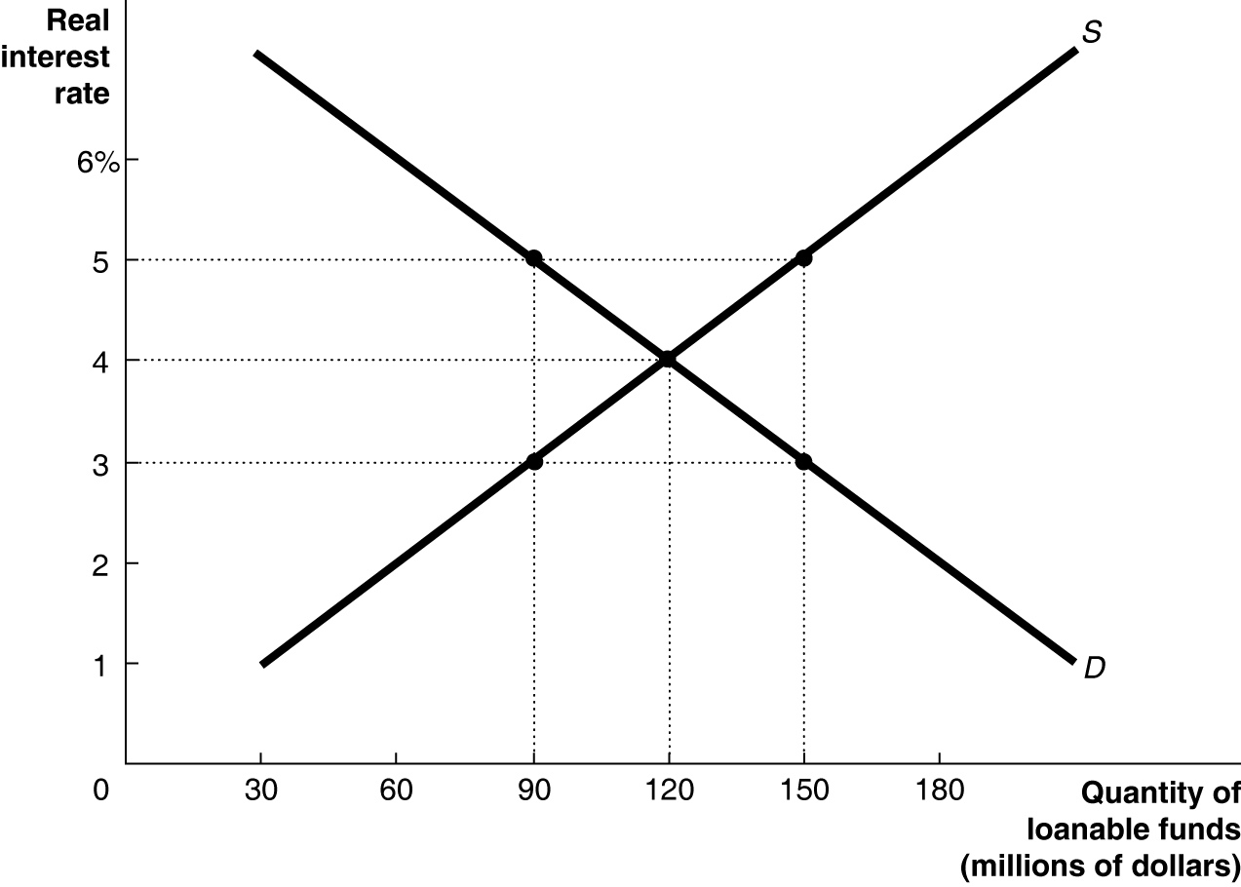

16) Refer to Figure 6.6. The loanable funds market is in equilibrium, as shown in the figure above. As a result of an increase in the government budget deficit, the ________ for loanable funds will ________, thereby ________ the equilibrium real interest rate and ________ the equilibrium quantity of loanable funds.
A) demand; fall; decreasing; decreasing
B) supply; fall; increasing; decreasing
C) demand; rise; increasing; increasing
D) supply; rise; decreasing; increasing
E) demand; rise; increasing; decreasing

17) How will an increase in the government budget surplus as a result of lower government spending (with no change in net taxes) affect private saving in the economy?
A) Private saving will increase by less than the amount of decrease in public savings.
B) Private saving will decrease by less than the amount of increase in the budget surplus.
C) Private saving will increase by the amount of increase in the budget surplus.
D) Private saving will decrease by the amount of increase in the budget surplus.
E) Private saving will be unaffected by the increase in the budget surplus.

18) ________ spending follows a smooth trend whereas, ________ spending is more volatile and subject to fluctuations.
A) Investment; consumer
B) Government; consumer
C) Investment; government
D) Consumer; investment
E) Consumer; government

19) Which of the following is a true statement about the multiplier?
A) The multiplier only applies to government spending.
B) The smaller the MPC, the larger the multiplier.
C) The multiplier is a value between zero and one.
D) The multiplier rises as the MPC rises.
E) The multiplier effect does not occur when autonomous expenditure decreases.

20) Which of the following leads to a decrease in real GDP?
A) households having increasingly optimistic expectations about future income
B) an increase in government spending
C) an increase in interest rates
D) an increase in the inflation rate in other countries, relative to inflation in Canada
E) an increase in imports

21) If the marginal propensity to save is 0.1, then a $10 million decrease in disposable income will
A) increase consumption by $1 million.
B) decrease consumption by $9 million.
C) decrease consumption by $1 million.
D) leave consumption unchanged.
E) increase consumption by $9 million.

22) Consumption is $5 million, planned investment spending is $8 million, government purchases are $10 million, and net exports are equal to $2 million. If GDP during the same time period is equal to $23 million, what unplanned changes in inventories occurred?
A) There was an unplanned increase in inventories equal to $2 million.
B) There was an unplanned decrease in inventories equal to $3 million.
C) There was no unplanned change in inventories.
D) There was an unplanned decrease in inventories equal to $19 million.
E) There was an unplanned decrease in inventories equal to $2 million.

23) If firms sell exactly what they expected to sell, all of the following will be true except
A) there is no unplanned change in inventories.
B) unplanned investment will be zero.
C) aggregate expenditure will be equal to GDP.
D) aggregate expenditure will be greater than GDP.
E) inventories will not change, and GDP and employment will remain stable.

24) If the consumption function is defined as C = 7,250 + 0.8Y, what is the autonomous level of consumption expenditure?
A) $1,425 B) $5,800 C) $7,250 D) $9,062.50 E) $9,700

25) All of the following are components of aggregate expenditure except
A) government spending.
B) actual investment spending.
C) net export spending.
D) consumption spending.
E) planned investment spending.

26) If economists forecast a decrease in aggregate expenditure, which of the following is likely to occur?
A) Inventories will fall.
B) GDP will rise.
C) GDP will fall.
D) Wages will rise.
E) Unemployment will fall.

27) Consumption spending is $16 billion, planned investment spending is $4 billion, unplanned investment spending is $2 billion, government purchases are $6 billion, and net export spending is $1 billion. What is aggregate expenditure?
A) $22 billion B) $26 billion C) $23 billion D) $27 billion E) $29 billion

28) Autonomous expenditure times the multiplier equals
A) autonomous saving.
B) government budget deficit.
C) equilibrium GDP.
D) autonomous consumption.
E) planned autonomous investment.

29) Canadian net export spending rises when
A) the growth rate of Canadian GDP is faster than the growth rate of GDP in other countries.
B) the value of the Canadian dollar increases relative to other currencies.
C) the price level in Canada rises relative to the price level in other countries.
D) the Canadian economy become more open to international trade.
E) the inflation rate is higher in Canada relative to other countries.

30) Given the equations for C, I, G, and NX below, what is the marginal propensity to save?

C = 1,000 + 0.8Y
I = 1,500
G = 1,250
NX = 100

A) 0.1 B) 0.2 C) 0.8 D) 1.8 E) 10

31) If an increase in autonomous consumption spending of $25 million results in a $100 million increase in equilibrium real GDP, then
A) the MPC is 0.25.
B) the MPC is 0.75.
C) the MPC is 0.8.
D) the MPC is 0.9.
E) the MPC is 2.5.

Figure 8.4

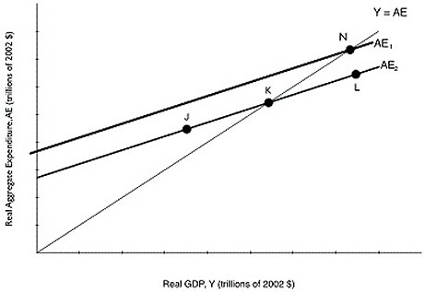

32) Refer to Figure 8.4. Suppose that the level of GDP associated with point K is potential GDP. If the Canadian economy is currently at point N,
A) the economy is in a recession.
B) firms are operating below capacity.
C) the economy is in an expansion.
D) the economy is at full employment.
E) the level of unemployment is above the natural rate.

33) The long-run aggregate supply curve shows the relationship between
A) the real interest rate and the nominal interest rate.
B) the quantity of real GDP supplied and the quantity of nominal GDP supplied.
C) the price level and quantity of real GDP supplied.
D) short-run aggregate supply and short-run aggregate demand.
E) the supply of labour and the price level.

34) Canadian National Railways (CN) plays such a large role in moving goods around the country that there is usually a close relationship between fluctuations in CN's business and fluctuations in GDP. When CN sees an increase in demand for its services, we can likely expect
A) an increase in unemployment.
B) a decrease in GDP.
C) a decrease in the price level.
D) an increase in GDP.
E) a drop in the exchange rate.

35) An economy is likely to recover from a recession quickly (without government intervention) when
A) it is caused by a negative supply shock and wages are fixed.
B) it is caused by a leftward shift in aggregate demand and wages are fixed.
C) it is caused by a leftward shift in aggregate demand and wages are flexible.
D) it is caused by a financial crisis.
E) it is caused by a leftward shift in aggregate supply and output prices are fixed.

36) The basic aggregate demand and aggregate supply curve model helps explain
A) which workers will lose their jobs during a recession.
B) long-term growth.
C) price fluctuations in an individual market.
D) output fluctuations in an individual market.
E) short-term fluctuations in real GDP and the price level.

37) The short-run aggregate supply curve has a(n)
A) slope equal to zero.
B) indeterminate slope.
C) negative slope.
D) positive slope.
E) slope equal to infinity.

38) If potential GDP is equal to $600 billion, what does the long-run aggregate supply curve look like?
A) It is a vertical line at a level of GDP below $600 billion.
B) It is a vertical line at $600 billion of GDP.
C) It is a positively sloped line beginning at the origin and passing through a GDP of $600 billion.
D) It is a vertical line at a level of GDP above $600 billion.
E) It is a horizontal line at $600 billion of GDP.

39) The aggregate demand curve shows the relationship between the ________ and ________.
A) real interest rate; quantity of real GDP supplied
B) inflation rate; quantity of real GDP demanded
C) price level; quantity of real GDP demanded
D) nominal interest rate; quantity of real GDP demanded
E) inflation rate; unemployment

40) Which of the following models focuses on how productivity shocks explain fluctuations in real GDP?
A) the new classical model
B) the new Keynesian model
C) the monetarist model
D) the Austrian model
E) the real business cycle model

41) Which of the following will shift the aggregate demand curve to the left, ceteris paribus?
A) an increase in disposable income
B) an increase in expected profits for firms
C) an increase in interest rates
D) an increase in net exports
E) an increase in the price level

Figure 9.5

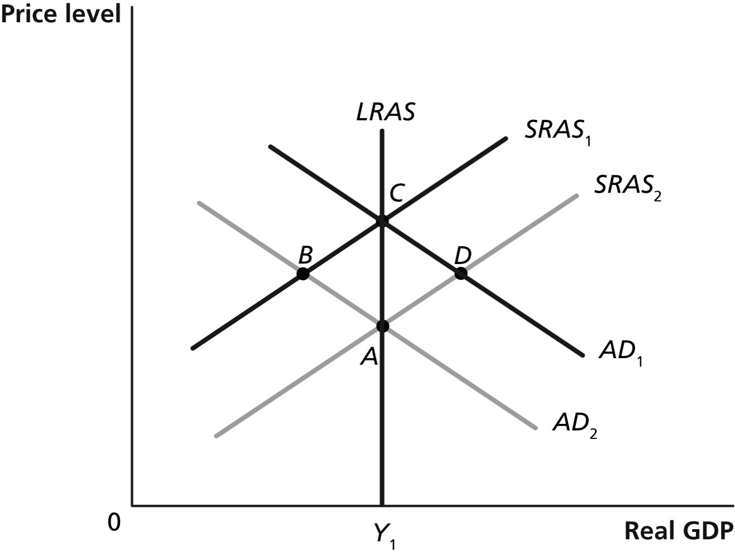

42) Refer to Figure 9.5. Which of the points in the above graph are possible short-run equilibria?
A) A and B
B) A and C
C) A and D
D) B and C
E) A, B, C, and D

43) During 2008-2009, falling oil prices
A) shifted the Canadian aggregate supply curve to the left.
B) shifted the Canadian short-run aggregate supply curve dramatically to the right.
C) shifted the Canadian aggregate demand curve to the left.
D) shifted the Canadian aggregate demand curve to the right.
E) shifted the Canadian long-run aggregate supply curve to the right.

Figure 9.5



44) Refer to Figure 9.5. Which of the points in the above graph are possible short-run equilibria but not long-run equilibria? Assume that Y1 represents potential GDP.
A) A and B B) A and C C) B and C D) C and D E) B and D

45) Ceteris paribus, in the long run, a negative supply shock causes
A) higher labour force participation.
B) unemployment to fall below its short-run level.
C) equilibrium real GDP to fall.
D) the price level to rise initially, and then return to its lower level.
E) the long-run aggregate supply curve to shift to the left.

46) Which of the following would cause the short-run aggregate supply curve to shift to the right?
A) a technological advance
B) an increase in the price of natural resources
C) a decrease in inflation expectations
D) an increase in the price level
E) an increase in interest rates

47) A falling price level will
A) increase the quantity of real GDP demanded.
B) increase aggregate demand.
C) decrease the quantity of real GDP demanded.
D) decrease aggregate demand.
E) have no impact on the quantity of real GDP demanded.

48) Proponents of the ________ model argue that the short-run supply curve is vertical.
A) new Keynesian
B) real business cycle
C) Austrian
D) monetarist
E) new classical

49) Economists and industry analysts pay close attention to the volume of rail cargo shipments because changes in rail shipments have historically been good indicators of
A) future economic activity.
B) future oil prices.
C) future exchange rate changes.
D) potential GDP.
E) past decreases in marginal tax rates.

50) The invention of the cotton gin ushered in the Industrial Revolution and began a long period of technological innovation. What did this technological change do the short-run supply curve?
A) It shifted the short-run aggregate supply curve to the right.
B) It gave the short-run aggregate supply curve a negative slope.
C) It moved the economy down along a stationary short-run aggregate supply curve.
D) It moved the economy up along a stationary short-run aggregate supply curve.
E) It shifted the short-run aggregate supply curve to the left.

51) In an open economy, the relationship between GDP (Y) and expenditures is Y = C + I + G.
A) True
B) False

52) The commonly accepted definition of a recession is at least two consecutive quarters of falling real GDP.
A) True
B) False

53) The formula for the multiplier is (1 - MPC).
A) True
B) False

54) A decrease in the price level in Canada will shift the aggregate expenditure line downward.
A) True
B) False

55) A decrease in disposable income will shift the aggregate demand curve to the left.
A) True
B) False

